NETWORK DESIGN AND “IMPLEMENTATION OF ENTIRE COLLEGE"



PROJECT REPORT SUBMITTED IN PARTIAL FULFILLMENT OF THE REQUIREMENTS FOR THE SEMESTER 5TH SUBJECT OF

COMPUTER NETWORK LAB

[COM-512]

COMPUTER SCIENCE ENGINEERING

SUBMITTED BY

NAME: Iftisam Tariq

ROLL NO: 2021a1l017

I

## CERTIFICATE

This is to certify that Computer Networking Lab (COM-512) Mini Project entitled “College Network Configuration” Submitted by Name: Iftisam tariq Roll no. 2021a1l017 section: A1 for the partial fulfilment of the requirement for Semester 5th Subject of Computer Networking Lab in the Department of Computer Science and Engineering of M.I.E.T Jammu, is a Bonafede work carried out during Semester 5th in Academic Year 2022-2023.

(signature)

Asst. Prof. MISS. VISHALIKA Date:

(signature) HOD

Dean Academics Affairs Dr. Ashok Kumar

II

|  |  |
| --- | --- |
| ABBRE | ATIONS |
| MSE | Mobility Service Engine |
| UCS | Unified Computing System |
| RFP | Request For Proposal |
| IP | Internet Protocol |
| RIP | Routing Information Protocol |
| RPP | Routing Protocol Plan |
| OS | Operating System |
| OSI | Open Systems Interconnections |
| FTP | File Transfer Protocol |
| DNS | Domain Name System |
| LAN | Local Area Network |
| VLAN | Virtual Local Area Network |

## LIST OF FIGURES

III

|  |  |  |
| --- | --- | --- |
| 1: | VLAN Configurations | 2 |
| 2: | Existing Infrastructure | 3 |
| 3: | Proposed Network | 4 |

|  |  |  |
| --- | --- | --- |
| 4: | RPP Router 0 | 9 |
| 5: | RPP Router 1 | 9 |
| 6: | RPP Router 2 | 9 |
| 7: | Prototype Of Proposed Network | 10 |
| 8: | Testing VLAN From HOD Cabin | 10 |
| 9: | Testing Web Hosting | 11 |
| 10: | Testing FTP Server | 11 |

IV

## CONTENTS

TITLE I CERTIFICATE II

ABBRIVATIONS III LIST OF FIGURES IV

|  |  |  |
| --- | --- | --- |
| 1: | Introduction | 1 |
| 2: | Objectives | 1 |
| 3: | Network Requirements | 1 |
| 4: | Major Design Areas and Functional Areas | 2 |
| 5: | Existing Infrastructure | 3 |
| 6; | Network Devices | 4 |
| 7: | Request for Proposal (RFP) | 6 |
| 8: | IP addressing Plan | 7 |
| 9: | Routing Protocol Plan | 9 |
| 10: | Network Design | 10 |
| 11: | Summary | 12 |
| 12: | References | 12 |

## INTRODUCTION

This College Network Configuration is about designing a topology of a network that is a LAN (Local Area Network) for a college in which various computers of different departments are set up so that they caninteract and communicate with each other by interchanging data. To design a networking scenario fora college which connect various departments to each other’s, it puts forward communication among different departments. CNS is used to design a systematic and well-planned topology, satisfying all thenecessities of the college (i.e., client). CNS come up with a network with good performance.

## OBJECTIVES

The main objective of the proposed network is to update the existing network and also enhance its capabilities and increase the flexibility of the network which will eventually provide good security.

## NETWORK REQUIREMENTS

1. The new system should be able to reduce internet downtime. Download and upload links should bemaintained above 5 Mbps speed requirement.
2. Network will be scalable.
3. The system should support remote access.
4. Should comprise of data centers with necessary security features and support.

## MAJOR DESIGN AREAS AND FUNCTIONAL AREAS

The new system planned comprises of IP based switches that remain as the access point to Lan-based (ethernet)as well as Wi-Fi-based connectivity.

These switches provide SNMP support as well so that traffic monitoring becomes easy.Ip based switches are used mainly because:

* + The inter VLAN routing feature is supported on both IP base or SMI and IP services or EMI image Layer 3 switches. For Layer 2-only switches, you require a Layer 3 routing device with any of theprevious images.

1

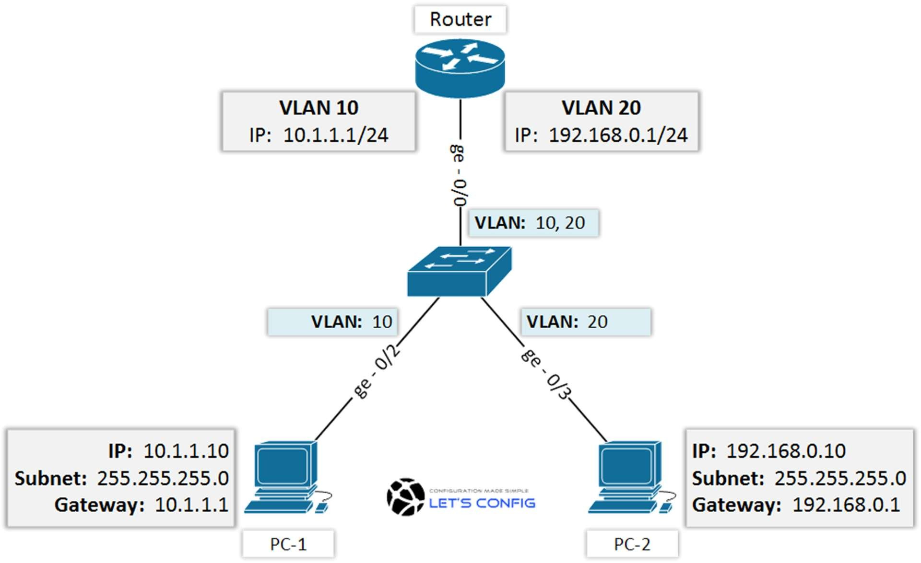

* + The IP Base feature set includes advanced quality of service (QoS), rate limiting, access control lists(ACLs), and basic static and Routing Information Protocol (RIP) functions. Dynamic IP routingprotocols (Open Shortest Path First (OSPF), BGPv4, Enhanced Interior Gateway Routing Protocol (EIGRP)) are available only on the IP services image.
  + The IP Services image provides a richer set of enterprise-class features, which includes advanced hardware- based IP unicast and IP Multicast routing. Support for IPv6 Layer 3 switching in hardwareis also available with the addition of the Advanced IP Services license to either the IP Base or the IPServices images. Both the IP base Image and the IP services image allow for Layer 3 and Layer 4lookups for QoS and security.

2

## EXISTING INFRASTRUCTURE

The existing system is a very basic system. College mainly comprises of three main sections as

1. TPO & Other
2. Exam Center
3. Office

All the hosts are assigned with static IPs and are assigned in the order in which it was set up.No support for dynamic IP allocations. Even though the working is divided into three major sectors all the host, multimedia devices are connected in a single network. Thus, network security and maintenance are difficult. One more problem observed was the existing switches were outdated and hence could not prove tobe beneficial for the network administrator to observe monitor and handle the network traffic the system hasno remote access to the network. Absence of basic small- scale businesses firewall was also observed. Thus,security is also compromised. Three server rooms were used for the purpose of independent networking which further caused wastage of power and money.

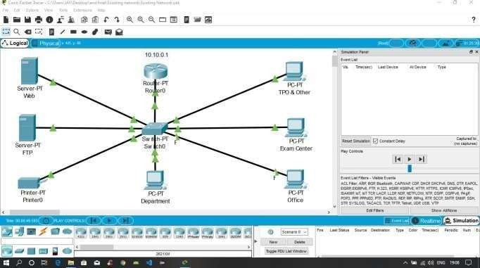

The above design is the existing network traced on cisco packet tracer.

3

## NETWORK DEVICES

Developing the existing Lan system:

* + The basis of the LAN core is Cisco Catalyst 6509 switches equipped with Cisco 720 supervisors andVirtual Switching System (VSS), as well as Cisco 4500 switches, combined in a stack with the data transmission ports at 10 Gb/s bandwidth capacity. Switches create a platform for additional services,such as content processing, firewall (the project uses the Cisco firewall), intrusion prevention system,application of IPsec security tools, the arrangement of protected VPN channels, network analysis andacceleration of Secure Sockets Layer (SSL) connections.

Mobility Services Engine (MSE) solution and 300 Cisco Aironet 1140 access points were used.

* + The Cisco Aironet 1140 Series is a component of the Cisco Unified Wireless Network, which can scale up to 18,000 access points with full Layer 3 mobility across central or remote locationson the enterprise campus, in branch offices, and at remote sites.
  + The Cisco Unified Wireless Network is the industry’s most flexible, resilient, and scalable architecture, delivering secure access to mobility services and applications and offering the lowest total cost of ownership and investment protection by integrating seamlessly with the existing wired network.

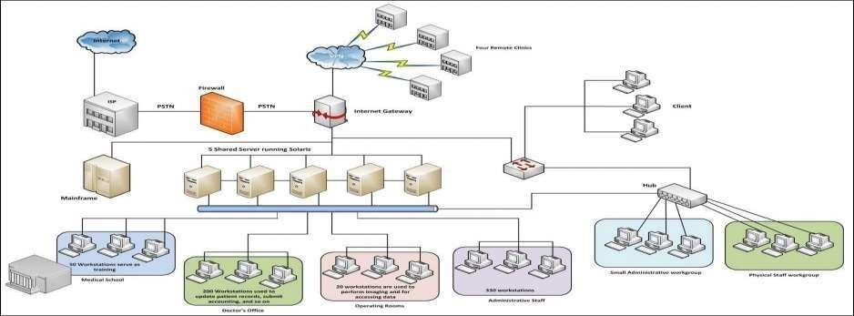

4

Cisco Unified Computing System (UCS) solution allowed the integration of computer and network resources as well as storage and virtualization systems as part of an energy efficiency system. Cisco Unified Computing System platform notably simplifies traditional architecture and significantly reducesthe number of devices to be purchased, to connect by wires, to supply with electricity and cooling, to protect and maintain.

This solution is the foundation of complex optimization of the virtualized mediumwhile maintaining the ability to support traditional operating systems and applications stacks in physicalmedium.

This overall infrastructure developed allowed integration of several functionally different physical networks into one, such as guest network, hotel management network, telephone network andIP-Television network.

The convergence within single network reduced hotel expenses for constructingand managing several dedicated networks which traditionally remain separate in hotels.

The term unified computing system is often associated with Cisco. Cisco UCS products have the ability to support traditional operating system (OS) and application stacks in physical environments, but are optimized for virtualized environments.

Everything is managed through Cisco UCS Manager, a software application that allows administrators to provision the server, storage and network resources all at once from a single pane of glass. Similar offerings to

Cisco UCS include HP BladeSystem Matrix, Liquid Computing's LiquidIQ, Sun Modular Datacenter and InteliCloud 360.

5

## REQUEST FOR PROPOSAL

|  |  |  |  |  |
| --- | --- | --- | --- | --- |
| Serial no | Network Devices | Price per unit (Approx.) | Quantity | Total cost (INR) |
| 1 | The Cisco System Businessswitches | 17,999 | 6 | 108,000 |
| 2 | Cisco RV042G: | 8000 | 3 | 24,000 |
| 3 | Wires | 25000 | 2 | 50000 |
|  | | | Total | 1,82,000 |

IP ADDRESSING PLAN

|  |  |
| --- | --- |
| IT DEPARTMENT (192.168.1.0) | |
| HOD CABIN | 192.168.1.2 |
| IT LAB 1 | 192.168.1.3 |
| IT LAB 2 | 192.168.1.4 |
| IT LAB 3 | 192.168.1.5 |

6

|  |  |
| --- | --- |
| IT LAB 4 | 192.168.1.6 |
| Printer 0 | 192.168.1.7 |

|  |  |
| --- | --- |
| COMPUTER DEPARTMENT (192.168.2.0) | |
| CS HOD CABIN | 192.168.2.2 |
| CS LAB 1 | 192.168.2.3 |
| CS LAB 2 | 192.168.2.4 |
| CS LAB 3 | 192.168.2.5 |
| CS LAB 4 | 192.168.2.6 |
| Printer 7 | 192.168.2.7 |

|  |  |
| --- | --- |
| OTHERS (192.168.3.0) | |
| OFFICE | 192.168.3.2 |
| Printer 2 | 192.168.3.6 |
| EXAM CELL | 192.168.3.3 |
| Printer 3 | 192.168.3.7 |
| ENQUIRY | 192.168.3.4 |
| TPO | 192.168.3.5 |
| Printer 4 | 192.168.3.8 |
| SERVER ROOM (1.0.0.0) | |
| FTP SERVER | 1.0.0.4 |
| PC1 | 1.0.0.5 |
| DNS SERVER | 1.0.0.2 |
| WEB SERVER | 1.0.0.3 |

7

|  |  |
| --- | --- |
| INTERNET LAB (128.168.0.0) | |
| PC2 | 128.168.0.2 |
| PC3 | 128.168.0.3 |
| PC4 | 128.168.0.4 |
| PC5 | 128.168.0.5 |
| Printer 5 | 128.168.0.6 |

|  |  |
| --- | --- |
| PRINCIPLE ROOM (192.168.4.0) | |
| PC 0 | 192.168.4.2 |
| LAPTOP 0 | 192.168.4.3 |

## ROUTING PROTOCOL PLAN

Routing Information Protocol (RIP) is a dynamic routing protocol which uses hop count as

a routing metric to find the best path between the source and the destination network. It is a distancevector routing protocol which has AD value 120 and works on the application layer of OSI model.

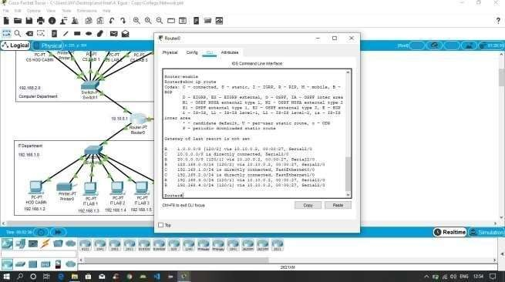

Routing Protocol Plan for Router0

8

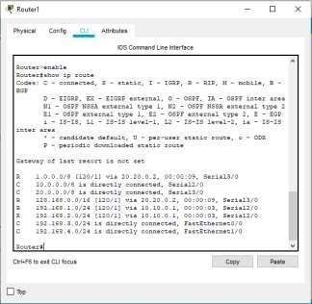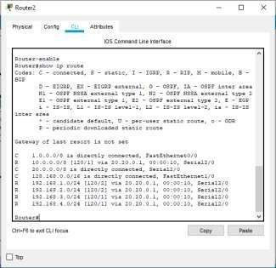

Routing Protocol Plan for Router1

## NETWORK DESIGN



Routing Protocol Plan for Router2

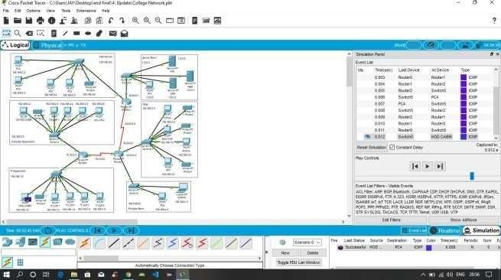

The prototype of the proposed network is implemented on cisco packet tracer

9

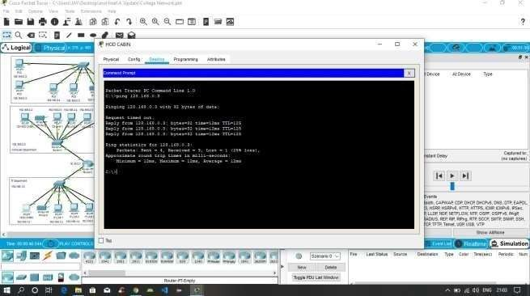

Testing VLAN communications from HOD Cabin to Internet Lab

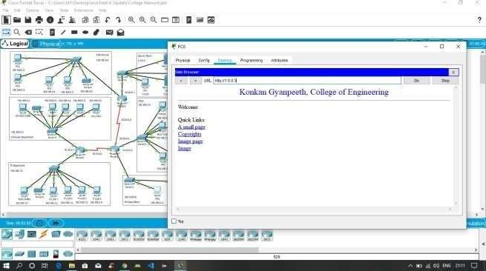

Testing Web Hosting

10

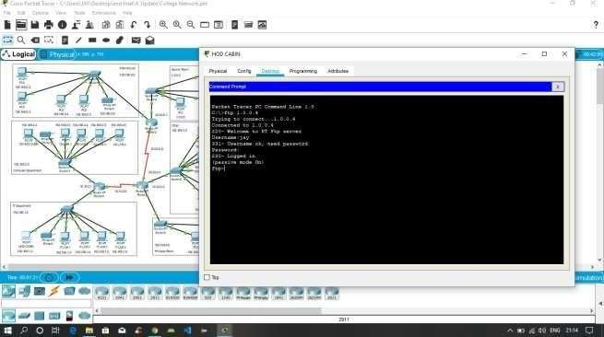

Testing FTP Server

11

# SUMMARY

The outcome of the proposed system will be a fail-safe backbone network infrastructure which meets the requirements for readily available access to information and security of the private network, and also ensures optimized productivity when telecommunication services are accessed. The installed equipment allowed to organize high-speed wired and wireless Internet access throughout the whole complex of hospital buildings as well as providing transfer of all types of data throughout the single optimized network.

12

# REFERENCES

1. Sun, L., Wu, J., Zhang, Y., & Yin, H. (2013, April). “Comparison between physical devices and simulator software for Cisco network technology teaching”. In Computer Science &Education (ICCSE), 2013 8th International Conference on (pp. 1357-1360). IEEE
2. Roberto Minerva AbiyBiru, "Towards a Definition of the Internet of Things” IEEE IOT Initiative white paper.
3. “Design and Simulation of Local Area Network Using Cisco Packet Tracer”. The International Journal of Engineering and Science (IJES) || Volume || 6 || Issue || 10 || Pages || PP 63- 77 || 2017 || ISSN (e): 2319 – 1813 ISSN (p): 2319 – 1805.
4. Qin, X. U. E. "Simulation Experimental Teaching of Computer Network Based on Packet Tracer [J]." Research and Exploration in Laboratory 2 (2010): 57-59.
5. Current, John R., Charles S. ReVelle, and Jared L. Cohon. "The hierarchical network design problem." European Journal of Operational Research 27.1 (1986): 57-66.

13